Supplemental Nutrition Assistance Program (SNAP) 2017

What is SNAP? This was formerly known as the Food Stamp program. It provides food purchasing assistance for low and no-income people living in the U.S. It is administered by the U.S. Department of Agriculture. Fourteen per cent (14.3%) of the U.S. population receives food stamps. This is 41,970,417 people as of 3/2017, a drop of 2,374,357 compared to 3/2016. The average monthly benefit is $124.89. Household, $252.80
In Connecticut, 11.0% of the population is receiving food stamps, 391,810.
The average monthly benefit is $132.

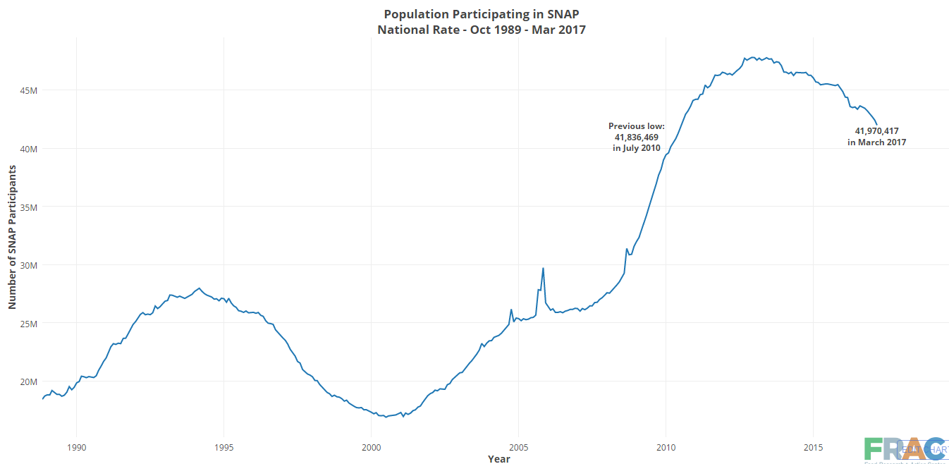

Who Receives SNAP Benefits?

SNAP benefits have always been targeted to the neediest households and most vulnerable populations. In 2015, more than half of all SNAP benefits went to households with gross incomes at or below half of the poverty line and 93% went to households with incomes below the poverty line.
Three-quarters of SNAP recipient households had a child, an elderly member, or a member with a disability.
Children, seniors, and adults with disabilities made up 64% of all SNAP recipients in 2015.
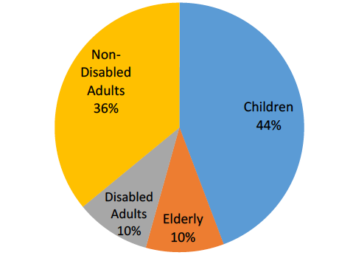
Nationally, SNAP lifted 4.6 million people out of poverty – 2.2 million children – 2015
In CT, the monthly average number of SNAP recipients is 432,000 in fiscal year 2016.

Is SNAP effective?
The Supplemental Nutrition Assistance Program (SNAP) is the cornerstone of U.S. efforts to alleviate hunger by supplementing the food budgets of low-income households. The large majority of SNAP recipients are children, working parents, elderly Americans, and people with disabilities. SNAP has also played an important role in lifting millions of people—especially children—out of poverty for the past five decades.

A growing body of high-quality research shows that SNAP is highly effective at reducing food insecurity, and in turn has important short-run and long-run benefits for low-income families. SNAP’s benefits are especially evident and wide-ranging for those who receive food assistance as children; they extend beyond the immediate goal of alleviating hunger and include improvements in short-run health and academic performance as well as in long-run health, educational attainment, and economic self-sufficiency.

In 2015, SNAP help lift 4.6 million Americans out of poverty.

What legislation effects SNAP?

President Trump’s 2018 budget would undermine SNAP by ending SNAP’s status as a national program and shifting more than $100 billion of SNAP costs over the next decade to the states by forcing states, for the first time, to pay a share of SNAP benefit costs — 10 percent starting in 2020, rising to 25 percent in 2023 and beyond. The budget also would give states new flexibility to cut SNAP benefit levels to “manage their costs” ― flexibility that many states would likely use. The result: more people at risk of hunger and harsher, more damaging, and longer economic downturns.

What can you do?

You can contact your congress person and ask them to oppose this action against SNAP.
SNAP is the one program that has been shown to decrease poverty and it is important that we continue to support this program.

Facts on the Supplemental Nutrition Program (SNAP), previously known as Food Stamps

SNAP acts as a safety net for the elderly, disabled, children, low -income workers and those unemployed who cannot find work (3 month limit)

In CT, 400,000 receive food stamps

What is the average income for people on SNAP? 117% of the poverty level.
The poverty level is $24,250 for a family of 4. 117% of the poverty level is $28,372.
Right now, people making up to 130% of the poverty level are eligible for SNAP.

The current federal budget proposal is to cut 25-29% of the SNAP budget over 10 years. To achieve this, eligibility will need to be cut. For example, for a family of 4, that would mean that eligibility would need to be set at 68% of the poverty level> $16,490.

By 2021, a family of 4 would face cuts of $165/month or $2000/year.

Other suggested changes in SNAP…

If there was more than 6 people in a household, the maximum benefit stops at $925/month.

Able bodied people must work 20 hours/week, minimum. Currently, that is 58,000 people in CT.
The average time on SNAP is 9 months.

Because SNAP eligibility is tied to free school lunches, children would also be cut from school lunch or towns would need to increase administrative staff to assess who is eligible

It is proposed that the states pick up 25% of the cost of SNAP.

In summary…..Cuts to safety net programs like SNAP will increase the number of hungry people and children in the United States.

Children from families struggling with hunger may be more likely to:
Repeat a grade in elementary school
Experience developmental impairments in areas like language and motor skills
Have more social and behavioral problems

The lack of food effects children from obtaining their full potential and ultimately costs the U.S. more money for education and social constraints

