Date:
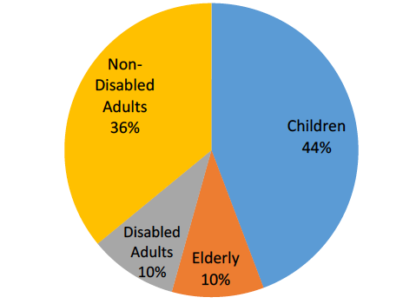
Dear Representative/Senator:

There has been much talk about changing the Supplemental Nutrition Assistance Program (SNAP) structure and turning the funds over to governors and state legislators. For the 42 million Americans relying on the SNAP program, we urge you to reject this proposal.

Shifting the cost to states, and limiting states to a set amount of funding, means that states would be faced with impossible choices as need increased: Do they cut benefits, or do they place children and seniors on waiting lists for food assistance? Doing so would roll back a generation of progress against very deep hunger, and destroy a bipartisan compact that has developed and sustained a strong and effective national nutrition safety net. If SNAP is changed in this way, many millions of seniors, people with disabilities, children, struggling parents – working and unemployed – and others will suffer. Our country will also see more hunger and poverty, worse health and educational outcomes, and higher health costs. The nation as a whole will be weaker – morally, economically, and fiscally and children will disproportionately be effected.

I ask that you oppose efforts to weaken SNAP’s structure or benefits. I ask you to co-sponsor bills to raise SNAP’s structure rather than diminish it. It is also important that you oppose any proposals that states pick up 25% of the cost and that reduces the eligibility requirements.

Thank you for supporting the current structure of SNAP and voting in a way that supports people in poverty.

Sincerely,

Name
Town

