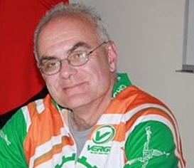

Tom is a Theology and American History teacher at Fairfield Prep. He lives in Rocky Hill with his wife and two sons.
Twenty five years experience in Christian Service Learning education has brought me into relationship with those who suffer material poverty on the local, national and international levels. Brake the Cycle has given me the opportunity to engage my passion for social justice born of those experiences with my interests in cycling and raising awareness around poverty issues.

