State of Connecticut
The Budget as A Justice Issue
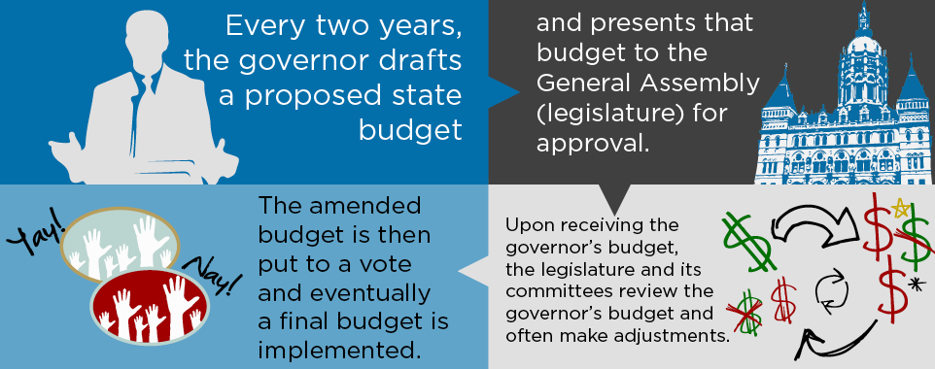
Where does the money come from?
Personal income taxes fund over 52% of the state budget. How, you might ask, can more than half of state revenue come from a tax that did not exist before 1991? Or did it . . .
Before 1991
Capital gains were taxed at 7%
Dividends and interest were taxed between 1% and 14%
After 1991
The capital gains tax was reduced to 4.75% in 1991; repealed in 1992
Dividends and interest were taxed between 0.75 % and 9.5% in 1991; repealed in 1992
State income tax introduced at 1.5% in 1991; raised to 4.5% in 1992 and after
So…..
What actually happened in 1991 was that the wealthiest citizens of the state received a tremendous tax cut while most residents experienced a tax hike!
But . . . this can be fixed!
“Broadening the sales tax base to include services (presently excluded such as boat and yacht storage, interior decorating services) while lowering the rate at the same time from 6.35% to 5.5% could generate $730 million in new revenue annually.”
(Above attributed to Connecticut Voices for Children)
The state could also modestly raise the tax rate on those earning more than $500,000, but Governor Malloy insists that he will not “tax success”. Our rate illustrates that:
NEW YORK: 8.82% NEW JERSEY: 8.97% CONNECTICUT: 6.99%
Tell your legislators that the budget is a justice issue!
Dear Legislator,
I am a constituent deeply concerned about the budget crisis facing our state. I have recently learned that Connecticut has the lowest tax rate in the tri-state area on those earning the most. Please encourage our lawmakers and our governor to address this justice issue. Even a modest increase could save jobs and help our most vulnerable citizens. I would also ask you to encourage our lawmakers to lower the sales tax rate while increasing the base to include currently untaxed services such as boat storage. Millions of dollars in revenue could be raised by addressing these areas of concern alone.
Thank you!

The sample letter below can help to get you started!

